**The Nassau Country Track Coaches Association Holiday Invitational**

**Saturday, December 12th, 2015 at the Ocean Breeze Track Complex**

**10AM Start – 625 Father Capodonno Blvd. Staten Island, NY 10305**

*We would like to thank all of our coaches, officials, and student-athletes who provide their time and effort to make this invitational a success each indoor season. All of the proceeds raised through this meet go directly back to the track and field athletes of Nassau County.*

**SITE OF THE 2017, 2018, AND 2019 NEW YORK INDOOR STATE CHAMPIONSHIPS!**

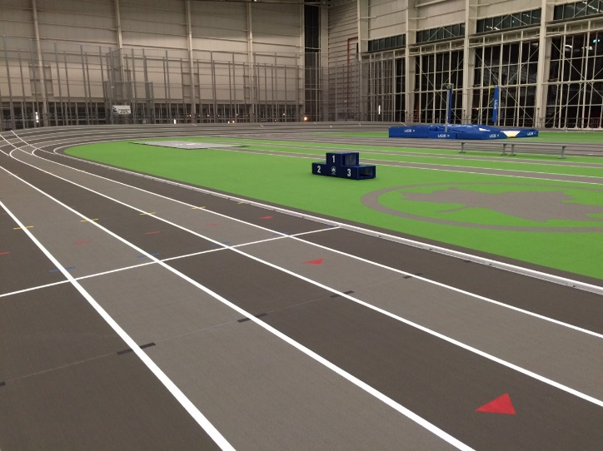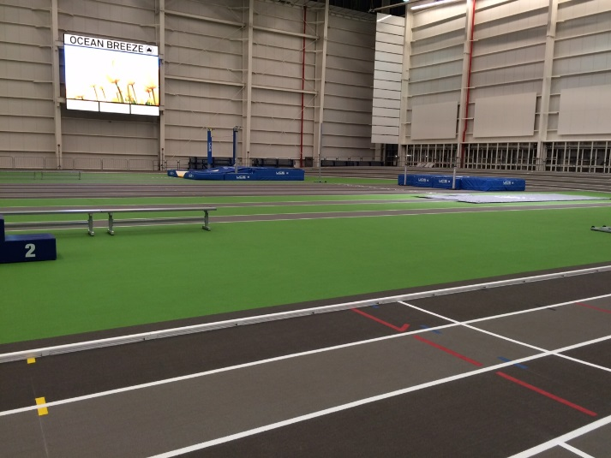

**This invitational is currently only open to Nassau County high schools and**

**teams who have attended our indoor invitational previously.**

**Important Notes for the Meet**:

1. Declaration: Any schools wishing to compete must e-mail Michael Ringhauser stating their intent to compete ([michael.ringhauser@yahoo.com](mailto:michael.ringhauser@yahoo.com)). This is being done to ensure that we have completed labels ready to be picked up the morning of the invitational.
2. Rosters: All teams must enter their complete roster on the Direct Athletics website by **December 5th, 2015 at 8:00pm**. Labels for your athletes will be printed for you based on the roster that you submit and be included in your meet packet. **No rosters or entries can be accepted after the deadline as Ocean Breeze needs to be informed of the teams attending in order to print the labels that are needed.**
3. Events and Seeding: Athletes are limited to any **two events** at the invitational. Clerking for all of the running events will occur near the throwing cages. Clerking for all field events will occur at the event itself.

*Individual Events*: Verbal seeding with the athletes checking in with their label.

*Relay Events*: Index card with SCHOOL NAME, SEED, and LABELS of the four

athletes competing on the relay.

1. Awards: NCTCA Medals for the Top 6 Individuals and Relays

**55 Dash Only** - Top 3 in Heats 1-10 will earn medals

**55 Hurdles Only** – Top 3 in Heats 1-5 will earn medals

1. Spikes: **¼ inch** spikes are acceptable in **all events**.

Order of Events: 9:45am - Clerking begins for the 55 Hurdles, 1000, and Field Events

9:50am - Coaches Meeting on the In-Field

**Running Events:** *FAT Timing in All Events!*

|  |  |
| --- | --- |
| **55 Hurdles** | Open Division Only – Event will take place on the in-field. |
| **55 Dash** | Open Division Only – Event will take place on the in-field. |
| **1000** | Open Division (Boys, Girls) – Followed by Frosh/Soph (Boys, Girls) |
| **600** | Open Division (Boys, Girls) |
| **300** | Open Division (Boys, Girls) – Followed by Frosh/Soph (Boys, Girls) |
| **1600/1500** | Open Division (Boys - 1600, Girls - 1500) |
| **4x200** | Open Division (Boys, Girls) – Followed by Frosh/Soph (Boys, Girls)  *Limit of 2 Open and 2 Frosh/Soph Relays per Gender* |
| **4x400** | Open Division (Boys, Girls) – Followed by Frosh/Soph (Boys, Girls)  *Limit of 2 Open and 2 Frosh/Soph Relays per Gender* |
| **4x800** | Open Division (Boys, Girls) – Followed by Frosh/Soph (Boys, Girls)  *Limit of 2 Open and 2 Frosh/Soph Relays per Gender* |

**Field Events**:

|  |  |
| --- | --- |
| **Long Jump** | Open Division (Boys, Girls) – All first jumps will be recorded.  Additional Measurements: Boys – 17 and over; Girls – 14 and over |
| **Triple Jump** | **This event will take place upon the conclusion of the long jump.**  Open Division (Boys, Girls) – All first jumps will be recorded.  Additional Measurements: Boys – 36 and over; Girls – 28 and over |
| **Shot Put** | **Boys’ competition will take place in the cage furthest from the bleachers.**  Open, Followed by Frosh/Soph – All first throws will be measured.  Additional Measurements: Open – 35 and over; F/S – 30 and over  **Girls’ competition will take place in the cage closest to the bleachers.**  Open, Followed by Frosh/Soph – All first throws will be measured.  Additional Measurements: Open – 25 and over; F/S – 20 and over |
| **Weight Throw** | **This event will follow the completion of the boys’ shot put in the cage furthest from the bleachers.**  Open Division (Boys, Girls) |
| **High Jump** | **This event will take place on the in-field following the finish of the 55.**  **Boys’ competition will be on the mats closest to the throwing cages.**  Open Division (5-0 opening height); Followed by Frosh/Soph (4-6 starting)  **Girls’ competition will be on the mats closest to the finish line.**  Open Division (4-0 opening height); Followed by Frosh/Soph (3-6 starting) |
| **Pole Vault** | Open Division (Girls, Boys)  Girls will have a 7-0 opening height; Boys will have an 8-0 opening height |

Additional Notes: - There are two jumping pits, so boys and girls will jump simultaneously.

* Unlimited entries in all running events except for the relays (see above notice).
* In the field events all first jumps/throws will be measured, then standards follow.
* There will be a DJ and photographer on hand at the invitational.
* **All meet entry prices across the board have dropped drastically from last year!**

**The Nassau County Track Coaches Association Holiday Invitational**

**Please Fill in the Grid Below *EVEN IF YOU ARE ENTERING A BLANKET ENTRY*!**

|  |  |  |  |  |
| --- | --- | --- | --- | --- |
|  | **Boys Open** | **Boys Fr./So.** | **Girls Open** | **Girls Fr./So.** |
| 55 Hurdles |  | XXXXXXXXXXXX |  | XXXXXXXXXXXX |
| 55 Dash |  | XXXXXXXXXXXX |  | XXXXXXXXXXXX |
| 1000 |  |  |  |  |
| 600 |  | XXXXXXXXXXXX |  | XXXXXXXXXXXX |
| 300 |  |  |  |  |
| 1600/1500 |  | XXXXXXXXXXXX |  | XXXXXXXXXXXX |
| 4x200 |  |  |  |  |
| 4x400 |  |  |  |  |
| 4x800 |  |  |  |  |
| Long Jump |  | XXXXXXXXXXXX |  | XXXXXXXXXXXX |
| Triple Jump |  | XXXXXXXXXXXX |  | XXXXXXXXXXXX |
| High Jump |  |  |  |  |
| Pole Vault |  | XXXXXXXXXXXX |  | XXXXXXXXXXXX |
| Shot Put |  |  |  |  |
| Weight Throw |  | XXXXXXXXXXXX |  | XXXXXXXXXXXX |

School: ________________________________________________________

Coach: ____________________________ Phone: ___________________

E-mail: ________________________________________________________

Option One: # of Individual Events Entered: _____ x $6 = $__________

# of Relay Events Entered: _____ x $25 = $__________

*Total Amount of the Entry:* $__________

Option Two: Blanket Entry of $250 if Entering a Boys’ or Girls’ Team Only

***$100 Less than Last Year and $200 Less than Previous Years!***

Blanket Entry of $475 if Entering a Boys’ and Girls’ Team $ __________

**Nassau County Schools will be Billed for Officials through BOCES**

**Send All Entries To**:

*Mail:* Fred DeRuvo – NCTCA *Fax:* 516-334-5461

730 Boelsen Drive **Please fax only between 8am-8pm!**

Westbury, NY 11590

*Checks are Payable to: NCTCA Tax ID: NCTCA 421705038*

**DO NOT FORGET ALSO TO**:

1. E-mail [michael.ringhauser@yahoo.com](mailto:michael.ringhauser@yahoo.com) of your intention to compete.
2. Enter your roster on [www.directathletics.com](http://www.directathletics.com) by 12/5/2015 at 8:00pm.